**Student Thesis / Research Guide**

**Developing a *Transformational Conversations* Research Process**

From the above definitions, we can define a of research.

The *Transformational Conversations* process of research is present across various disciplines:

* It’s termed *Participatory-Action Research (PAR)* in Education or Development theory,
* *Case Study Methodology* in Business research (for those focused on social entrepreneurship),
* In Theology, it is often called *Grounded Research*,
* Or yet again some aspects of the Catholic *Pastoral Cycle* also give some wider research processes that can be related to the concept of *Transformational Conversations.*

The step-wise method we will use for the MATUL Final Research Project can be mapped out as follows:

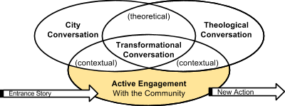

**1. Intentional Presence.** First is your locus among the people. Your obedience to the incarnate one. Be wholly in the community you wish to work with, fully participative in learning their ways, concerns, and delights. Attune yourself to the community’s assets, and needs, as they perceive them.

**2.** **Community Partners.** At this point you begin to identify who you are working with in the community, be it church, community organization, or NGO. For your research will lead to collective action, so at the outset you need to be embedded with a cluster of relationships to those likely to take significant action. *Aim to work with a grassroots neighborhood or ‘people’s organization’ that is made up of people in the community, who have organized themselves to work on behalf of the community. (In some cases, an outside organization may have come in and gathered leaders in the community around a common cause.)*

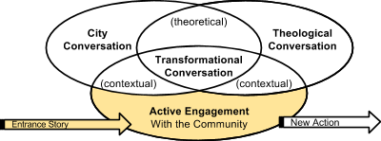

**3. Define an Issue.** Meet *with* your chosen *community partners* to learn what issues they’re interested on working on. What discontinuity *(or glitch in the system)* marks the conversations of the people among whom you dwell? The poignant experience begins to define your research topic. Be sure that the topic/idea is coming not so much from you, but from the voiced concerns of the organization with whom you’ve chosen to partner for this project. *(This is to ensure that you’re serving a need that the community wanted to work on anyway, and that they will have the drive to continue on with it even after you have left, because they’ll feel it’s “our” project, not just yours. The point is to produce real community benefit, not just a paper.)*

**4. Preliminary Research.** How has this issue been addressed -- by our community and others?

**a. Get the Local Back-Story.** Ask your community partners what has already been done by locals in response to this issue. What was positive/negative about their approach? It may have been intuitive. It may have been sudden, a wave of violence. It may have been the imposition of some foreign concept of what needs to happen, like rescuing girls from the slave trade through legal cases funded form a cluster of New York lawyers wishing to good. It may be an NGO seeking to fulfil its foreign donors’ expectations. A response, perhaps largely un-thought-through. This may be in the history of the people or evolving yet today. 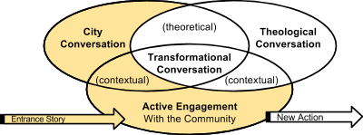

**b. Get a Wider Perspective.** Given that the issue remains unsolved, the local response method evokes questions, uncertainties about the nature of the issue. See if you can pinpoint what shortcoming you want to research in your literature review, or where you might look to find other communities that have addressed this same dilemma more successfully?

**5. Begin your Literature Review.**

* How that issue is dealt with elsewhere?
* What’s the conversation **across the city** about the issue (a local literature search is important here) ...and across the **global** literature?
* As you get at some underlying root causes of your issue, your literature research begins to focus on the social or the economic or the educational, etc.

**6. Engage the Theological Conversation.** Begin with the preaching that occurs in the local communities and the talk among leaders -- how are these aligned (or unaligned) with a Kingdom response? What new ideas, rooted in Scripture, would you introduce to the community? Or how can you take something that’s already being preached, and apply it to this situation? 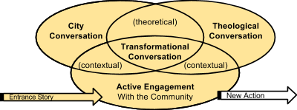

**7. Define your Research Question.** What approach to addressing the issue are your community partners interested in investigating further and trying out? How would it need to be **adjusted to fit your cultural context** and specific needs? What **gaps in the literature** require you to investigate or solve your specific, contextualized issue in a new, creative way?

**8. Further Research.** You then have two necessary lines of research that deepen your knowledge:

(1) Anthropological / social / economic / development / political research (City Conversation)

(2) Biblical and theological research (Theological Conversation)

You have to cut these processes two ways:

(a) From among the people,

(b) And from among the global or citywide conversation on the same issues. 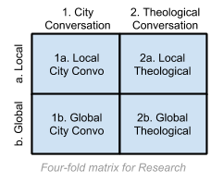

Thus you end up with a four-fold matrix. *(See diagram at right.)*

**9. Applying Theory to Contextualized Action.** Underlying these four dynamics is the discussion as to action. How does the theology predict new actions? How does the literature predict it? How do the social science perspectives predict it?

**10. Involve Community Partners.** The tricky thing is that action research depends on the actors. And you yourself are likely not the actor. You may be the catalyst, the interpreter, the theologian, etc. Be sure your *community partners* define the parameters & significance of your questions, of possible further action, of the range of Biblical interpretation that fit the situation.

Your research then becomes a servant to the development, or expansion of action into new structural forms. When effective, and accepting of well thought out issues by/with ‘insiders,’ this is wonderfully motivating. When narrowly defined by ‘outsiders,’ (often by foreign donor mandates), this can be totally frustrating. It is wise early on to consider these limits. Your research is but a tool for decision-makers. They face many other pressures, so considering early on how it flows with structural outcomes will save you from a lot of angst.

Keeping frequent and close correspondence with your community partners will also guide you in defining processes in your research and in upfront setting up communications pathways for your research such that the optimal decisions are made by the community or organization.

**11. Your Final Research Report.** *What will you need to produce, publish?* All you prepare to present, you have to do at a dual level. *(Your results should be accessible/understandable/relevant to two different audiences:)* (1) At the level of story-telling in the community and (2) at the level of the academe to earn a masters research project or thesis with a written documentation of your process at an appropriate academic level that contributes to the expansion of knowledge.

**12. Equip Your Community for Action.** Plan on presenting your results to your community partners. This public presentation is what you will leave with the community to help spur them toward the next steps in the co-designed action plan. It is separate from the more theoretical/technical academic piece you prepare as your ‘thesis’ / ‘research report.’ 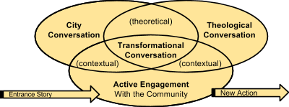

Spurring this “new action” completes the cycle of the *Transformational Conversations* research process.